**Assignment -1**

Python Programming

|  |  |
| --- | --- |
| Assignment Date | 19 September 2022 |
| Student Name | Ms. Soundaria S |
| Student Roll Number | 711319CS155 |
| Maximum Marks | 2 Marks |

1.Write a python program to test the given number is prime or not?

Solution:

def is_prime(num):

    count=0

    if(num>1):

        for i in range(1,num+1):

            if(num%i==0):

                count=count+1

    if(count==2):

        print("Prime")

    else:

        print("Not Prime")

num=int(input())

is_prime(num)

Output:

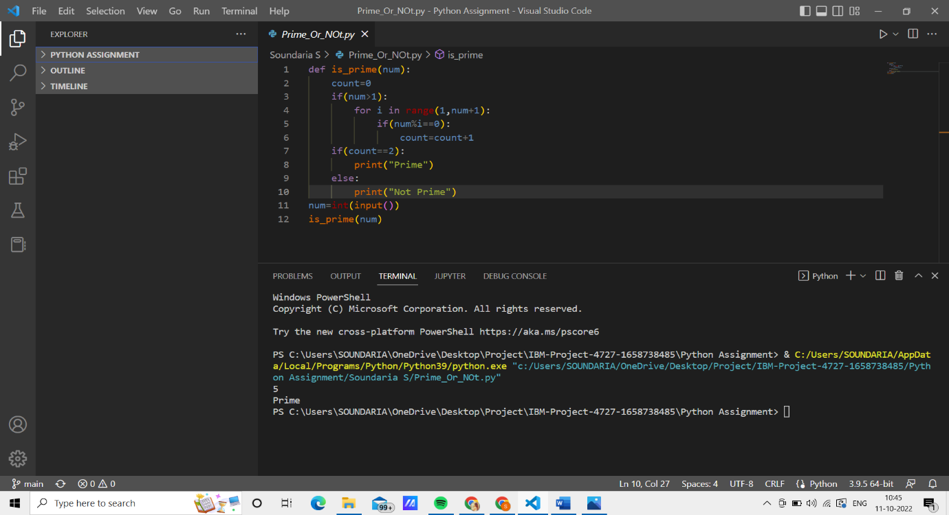

2.Write a program to generate odd numbers from m to n using while loop.

Solution:

m=int(input())

n=int(input())

while(m<=n):

    if(m%2!=0):

        print(m)

    m=m+1

Output:

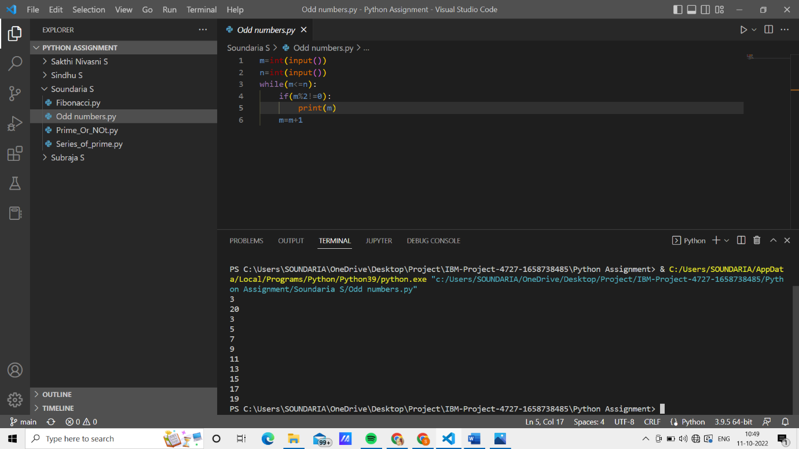

3.Write a program to generate a prime number series upto a given number.

Solution:

def prime(n):

    num=2

    while(num<=n):

        count=0

        if(num>1):

            for i in range(1,num+1):

                if(num%i==0):

                    count=count+1

        if(count==2):

            print(num)

        num=num+1

n=int(input())

prime(n)

Output:

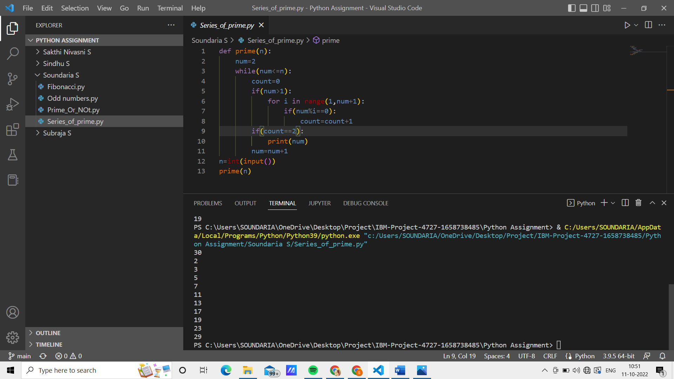

4.Write a python program to generate Fibonacci series.

Solution:

n=int(input())

n1, n2 = 0, 1

count = 0

if n <= 0:

   print("Please enter a positive integer")

elif n == 1:

   print("Fibonacci sequence upto",n,":")

   print(n1)

else:

   print("Fibonacci sequence:")

   while count < n:

       print(n1)

       nth = n1 + n2

       n1 = n2

       n2 = nth

       count += 1

Output:

